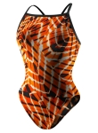

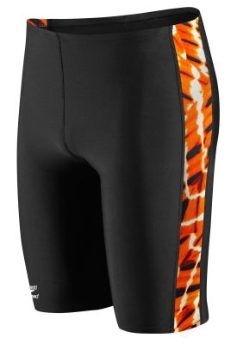

Speedo
Aqua Sites
ORANGE
TEAM PRICE
$44.95 + TAX = $49.13

SIZE: _________
PHOENIX
2110 E CAMELBACK
PHOENIX, AZ 85016
602.955.3939 STORE

E-MAIL SWIM@SKIPRO.COM

Fit date August 17th Friday
Deer Valley pool 333…………………;15

WE ACCEPT: CASH, VISA, MASTER CARD, AMEX, DISCOVER, AND CHECK (MAKE CHECK TO SKI PRO)
Speedo
Aqua Sites
ORANGE
TEAM PRICE
$33.95 +TAX=
$37.11

SIZE: __________
SKI PRO

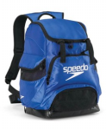
SPEEDO
BACKPACK
ORANGE OR ROYAL
TEAM PRICE
$59.95 + TAX=
$64.93

COLOR: __________



Custom Sweatshirt
$39.95 + TAX=
$43.22

SIZE: __________

SIZE: __________
__________


CUSTOM
FEMALE SHORT ORANGE
TEAM PRICE
$14.95 + TAX=
$16.19
SIZE: __________
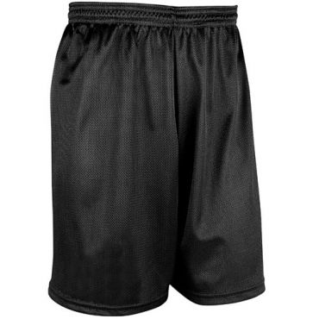
CUSTOM
MENS SHORT BLACK

TEAM PRICE
$19.95 + TAX=
$21.61
SIZE: __________

name: ________________________________________
phone: ______________________________________________________
email: _________________________________________________________

