SWIM

size_____

SIZE________

SPEEDO
TEAM Nano Fracture
Orange suit

TEAM PRICE
$65
INCLUDES TAX

GIRLS
SOFFE MESH SHORTS WITH LOGO

$21
INCLUDES TAX

BOYS
SOFFE MESH SHORTS WITH LOGO

$25
INCLUDES TAX

2110 E Camelback Rd
Phoenix, AZ 85016
602 955 3939 STORE

Team
Custom hoody
TEAM PRICE

$35
INCLUDES TAX

Team suit fitting will be on MONDAY AUGUST 25TH 3:00pm – 4:30pm at the pool

Speedo
TEAMSTER
backpack
CUSTOM
ORANGE
TEAM PRICE
$65
INCLUDES TAX

Name on bag:

_____________
SPEEDO
TEAM Nano Fracture
Orange suit
TEAM PRICE
$50
INCLUDES TAX

THUNDERBIRD HIGH SCHOOL ORDER FORM 2014

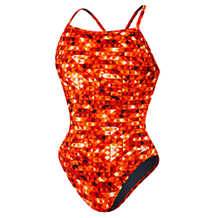

size_____

SIZE__________


size_____

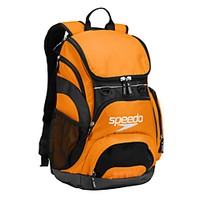

size_____

NAME: .CELL: ______________________

E-MAIL: TOTAL:_____________________

CASH, VISA, MASTER CARD, AMEX, DISCOVER, AND
Checks made out to: SKI PRO

SUIT SIZE

UNISEX SIZING_______

SUIT SIZE

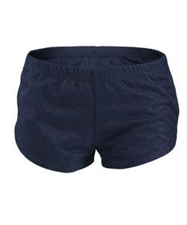
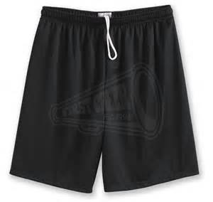
SKI PRO

